25-2-D-9 - PLARA - User Guide

1. Introduction
This guide provides instructions for using the PLARA application. its normal operational workflow for users and information on how to navigate the system successfully.
Make sure to download PLARA before use.

2. Getting Started
- Launch the App
Open the application on your Android device.
- Login
  - Enter your username.
  - Choose a group from the dropdown menu (Group 1 or Group 2).
  - Tap the flag to switch localization between English and Hebrew.
  - Tap Enter to access the main application.
- Place the Production Line
  - After entering, tap on the green floor to place the production line.

3. Main Interface Overview

Once the production line is placed, you will see the carts moving along the line. The interface allows you to:
- Observe the movement of the carts when the production line and the sensors are active.
- Open the menu at top left to access additional options.

4. Top Menu Options
Tap the menu button at the top left section to access the following features:
- Guides
  - Tap on each guide button to view their explanations and images for that station’s guide.
- Quiz
  - To complete the 5-question quiz, select an answer by tapping the answer number in the question.
  - Tap Next or Previous to navigate between answered questions and return to the current one.
- Badges
  - View badges related to activities performed in the app.
- Reset Placement
  - Place the production line to a different position as needed.
- Change User
  - Sign out from your current user account (See Sect. 2).
- End Demo
  - Displays your last completed quiz results.
  - QR code & button for external links:
    - Demonstration video
    - Station operating videos
    - Consent Form for Online Research
    - PLARA APKs.
    - Feedback form.
    - Station guides that are the same as in the app.
    - Google form quiz that is the same as in the app.
  - Tap Reset Demo to log out (See Sect. 2). Or close the app.
- Tap the flag to switch localization between English and Hebrew.
- Tap on the “Back” button to return to the main menu from any screen.
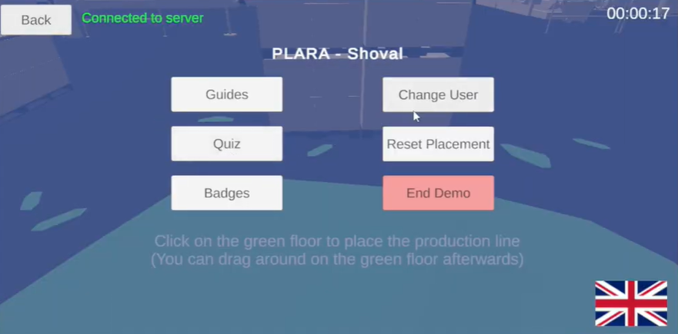

5. Using the Production Line
- Observe the movement of the carts when the production line is active.
- Use the “Reset Placement” option if you wish to change the position of the line.
- Monitor the interaction between carts and stations during the simulation.

6. Completing Quiz
- Select Quiz from the menu.
- Answer all 5 questions.
- Tap End Demo if you desire to end the session.

7. Ending Demo
- In the menu or post quiz, tap End Demo to finish the current session, view your last quiz and access external links.
- Feedback and demo evaluation to be submitted via the Links & QR provided, they are available in English or Hebrew.

